Practical 8: Binary Tree Traversals and Binary Search Tree
Insertion
Practical Aim
To implement binary tree traversals and binary search tree insertion, and develop the ability to reason about how the order of visiting nodes changes the information retrieved from a tree.
Problem 1:
A company stores its organizational hierarchy as a tree — the CEO at the top, managers below,
and employees at the leaves. Different departments need the hierarchy printed in different
orders: HR wants each manager printed between their left and right sub-teams, the archive
department wants each manager printed before their sub-teams, the payroll department wants
each manager printed after all their sub-teams are listed, and the floor manager wants everyone
printed level by level from top to bottom. Given a binary tree representing the hierarchy,
implement all four printing orders and display the result of each.
Describe how your solution for level-by-level printing differs from the other three. What
additional structure did you need to use, and why does the same recursive approach that works
for the other three not directly apply here?

For code :

https://github.com/kvvaghasiya49/FDSA/tree/6fb2f463bf1f58ac 408ada5ca8ffdaa64bc82087/DSA

Output:
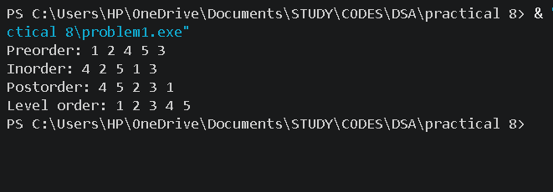

Problem 2
A school library uses a system where every book is assigned a unique code when it arrives.
Books are organized so that at any shelf position, all books to the left have smaller codes and
all books to the right have larger codes. This arrangement lets staff find any book quickly by
always knowing which direction to look. Given a sequence of book codes arriving one by one,
insert each into the correct position and print the inorder sequence after all insertions are
complete.
Describe how your solution decides where to place each new book code. What property of the
final inorder sequence tells you whether all insertions were performed correctly?
For code :

https://github.com/kvvaghasiya49/FDSA/tree/6fb2f463bf1f58ac 408ada5ca8ffdaa64bc82087/DSA

Output:

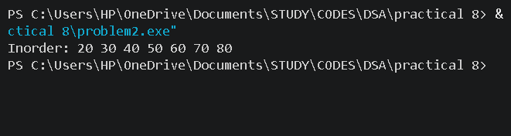

Challenges Faced:
The first difficulty was understanding that inorder, preorder and postorder are the same recursive function with only the position of the print line changed. In the beginning I kept mixing up the order of left, root and right, so my output did not match the expected output. Level order printing was different, because recursion goes deep into one side first, but level order needs to go across a whole level before going down. I solved this using a queue: I push the root, then repeatedly take the front node, print it, and push its left and right children. I also had to check that a child is not NULL before pushing it, otherwise the program crashed.

Learning Outcomes:
- I learned how to implement inorder, preorder and postorder traversals using recursion, and that they differ only in when the node is printed.
- I understood that level order traversal needs a queue, because it visits nodes level by level instead of going deep first.
- I learned how to insert a code into a BST by comparing it with each node and moving left or right until an empty position is found.
.

Key Questions / Analysis / Interpretation to be Evaluated During/After
Implementation:

1. [Problem 1] Preorder traversal always visits the root before anything else. Using only this property — without tracing any tree — explain whether it would be possible to reconstruct the original tree from its preorder output alone, and what additional information you would need if it is not.
Ans : It is not possible to reconstruct the original tree from the preorder output alone. Preorder tells us that the first element is the root, but after that it does not tell us where the left subtree ends and the right subtree begins. Many different tree shapes can give the same preorder sequence. For example, a node with only a left child and a node with only a right child give the same preorder output.
2. [Problem 2] The inorder traversal of a correctly built BST always produces a sorted sequence. If your inorder output is not sorted after all insertions, what does that tell you about where the error is — in the insertion logic, the traversal logic, or possibly both? How would you isolate which one?
If the inorder output is not sorted, the error can be in the insertion logic, the traversal logic, or in both. In the insertion logic, a wrong comparison, such as sending a smaller code to the right side, would break the BST property. In the traversal logic, printing the root before the left child or after the right child would give an unsorted order even if the tree is correct.

